Professional English Tutoring Pre-Tutoring Questionnaire

Parent/Guardian Details:
Full Name:
Address:
Email:
Mobile Number:

Student Details:
Full Name:
School:
Grade:
Email:
Mobile:
Current grade for English:
Goal for English grade:

Novels/Texts studying this year in English:

Areas of concern you would like to work on in our tutoring sessions (for example, battle formulating grammatically correct sentences, need to learn how to analyse deeply):

I have read and agreed to the Privacy Policy and the Terms and Conditions found at: https://www.professionalenglish.com.au/
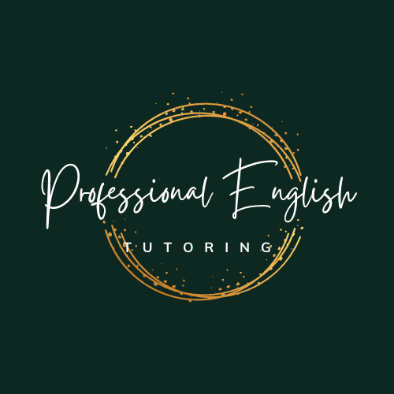

Parent/Guardian signature:
Student signature:

